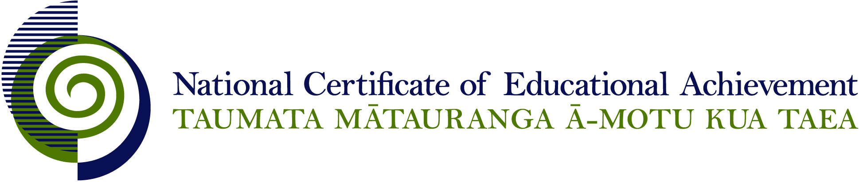

NCEA Level 3 Religious Studies

Conditions of Assessment

General Information

Subject Reference | Religious Studies
Domain | Understanding Religion
Level | 3

Conditions of Assessment

These Conditions provide guidelines for assessment against internally assessed Achievement Standards. Guidance is provided on:
- specific requirements for all assessments against this Standard
- appropriate ways of, and conditions for, gathering evidence
- ensuring that evidence is authentic.

Assessors must be familiar with guidance on assessment practice in learning centres, including enforcing timeframes and deadlines. The NZQA website offers resources that would be useful to read in conjunction with these Conditions of Assessment.

The learning centre’s Assessment Policy and Conditions of Assessment must be consistent with NZQA’s Assessment Rules for Schools with Consent to Assess. This link includes guidance for managing internal moderation and the collection of evidence.

Gathering Evidence

Internal assessment provides considerable flexibility in the collection of evidence. Evidence can be collected in different ways to suit a range of teaching and learning styles, and a range of contexts of teaching and learning. Care needs to be taken to allow students opportunities to present their best evidence against the Standard(s) that are free from unnecessary constraints.

It is recommended that the design of assessment reflects and reinforces the ways students have been learning. Collection of evidence for the internally assessed Standards could include, but is not restricted to, an extended task, an investigation, digital evidence (such as recorded interviews, blogs, photographs, or film), or a portfolio of evidence.

Effective assessment should suit the nature of the learning being assessed, provide opportunities to meet the diverse needs of all students, and be valid and fair.

Ensuring Authenticity of Evidence

Authenticity of student evidence needs to be assured regardless of the method of collecting evidence. This must be in line with the learning centre’s policy and NZQA’s Assessment Rules for Schools with Consent to Assess.

Ensure that the student’s evidence is individually identifiable and represents the student’s own work. The evidence must be an accurate reflection of what the student independently knows and can do, according to the Standard being assessed. This includes evidence submitted as part of a group assessment, evidence produced outside of class time or without assessor supervision, and evidence produced with any use of generative artificial intelligence tools (GenAI). GenAI use should be carefully considered in the context of the Standard being assessed and its Conditions of Assessment, discussed with students before the assessment, and its use must be acknowledged. For example, an investigation carried out over several sessions could include:
- teacher guidance on the nature and extent of acceptable GenAI use, if any
- assessor observations and conversations
- meeting with the student at set milestones or checkpoints
- the student’s record of progress, such as photographic entries or any GenAI prompts used.

Specific Information for All Internal Achievement Standards

Students should be given the opportunity to present evidence in a format that suits their individual learning style or the context of the assessment activity. Suggested formats include: computer-assisted presentation, timeline, journal, essay, brochure, poster, photo-essay, debate, role-play, drama performance, video, model, web 2.0 tools, and prepared speech.

Students may work on assessments individually or in groups. The contribution of each student needs to provide sufficient evidence for the assessment of that student and allow that student the opportunity to gain the standard with Achieved, Merit, or Excellence grades.

It is expected that the analysis is largely informed by material independently sourced by the student, with some guidance from a teacher or supervisor.

Students should have opportunities to work on assessments both in and out of class time.

Specific Information for Individual Internal Achievement Standards

Achievement Standard Number | 91725 Religious Studies 3.1
Title | Analyse the meanings in a sacred text within a religious tradition
Number of Credits | 6
Version | 1

Students should be guided towards the choice of interpretive methods, sacred text, and religious tradition to be used for the assessment activity through negotiation with the teacher or supervisor. Students may be guided to derive the relevant meanings from source material.

Achievement Standard Number | 90825 Religious Studies 3.2
Title | Analyse a religious tradition(s) in Aotearoa New Zealand
Number of Credits | 6
Version | 2

Students should be guided towards the choice of religious tradition(s) to be used for the assessment activity through negotiation with the teacher or supervisor.

Achievement Standard Number | 90826 Religious Studies 3.3
Title | Analyse the response of a religious tradition to a contemporary ethical issue
Number of Credits | 6
Version | 2

Students should be guided towards the choice of contemporary social issue and religious tradition to be used for the assessment activity through negotiation with the teacher or supervisor.

Achievement Standard Number | 90827 Religious Studies 3.4
Title | Analyse the key beliefs of a religious tradition and a secular world view in relation to ultimate questions.
Number of Credits | 6
Version | 2

Students should be guided towards the choice of secular world view, religious tradition, and ultimate questions to be used for the assessment activity through negotiation with the teacher or supervisor.

